Eastern Broadacre
The Eastern Broadacre Strategic Assessment is the next step in the planning of the Eastern Broadacre area as a future employment corridor. Eastern Broadacre is situated to the east of Canberra, extending from the Majura Valley in the north to Hume in the south and includes parts of Symonston and Jerrabomberra Valley (Figure 1).

Background
The ACT Planning Strategy 2018 and East Canberra District Strategy 2023 identified Eastern Broadacre for investigations into establishing new industrial and employment opportunities in parts of the area, while considering existing uses of the land and important environmental values.

What is a strategic assessment?
Ecology studies have identified that parts of Eastern Broadacre are home to both ACT and Commonwealth listed threatened species and habitats. The area contains critically endangered plants and animals, such as natural temperate grassland, striped legless lizard and the grassland earless dragon.
The Commonwealth’s Environment Protection and Biodiversity Conservation Act 1999 (EPBC Act) lists these species as Matters of National Environmental Significance (MNES). Actions that are likely to have a significant impact on MNES require approval under the EPBC Act.

Why do a strategic assessment?
A strategic assessment will allow the entire Eastern Broadacre area to be considered in one statutory process and through one document. It will assess the impacts of development on threatened species, giving a more holistic picture. Where proposed development may impact on MNES, environmental offsets will be required; these can be addressed strategically across the whole region. In other instances, development may avoid areas of MNES altogether.

Where will development and conservation areas be?
The sites that are subject to ecological field surveys are outlined in Figure 2, noting this shows current information and may be subject to future updates. These areas will contain future development and conservation areas.
The exact extent of development and conservation will be determined through this project. The strategic assessment will identify land suitable for industrial uses, environmental offsets and avoidance areas, informing future planning and potential rezoning of the area. Other uses and activities such as agriculture, rural tourism and recreation will also be considered in the preparation of the strategic assessment.
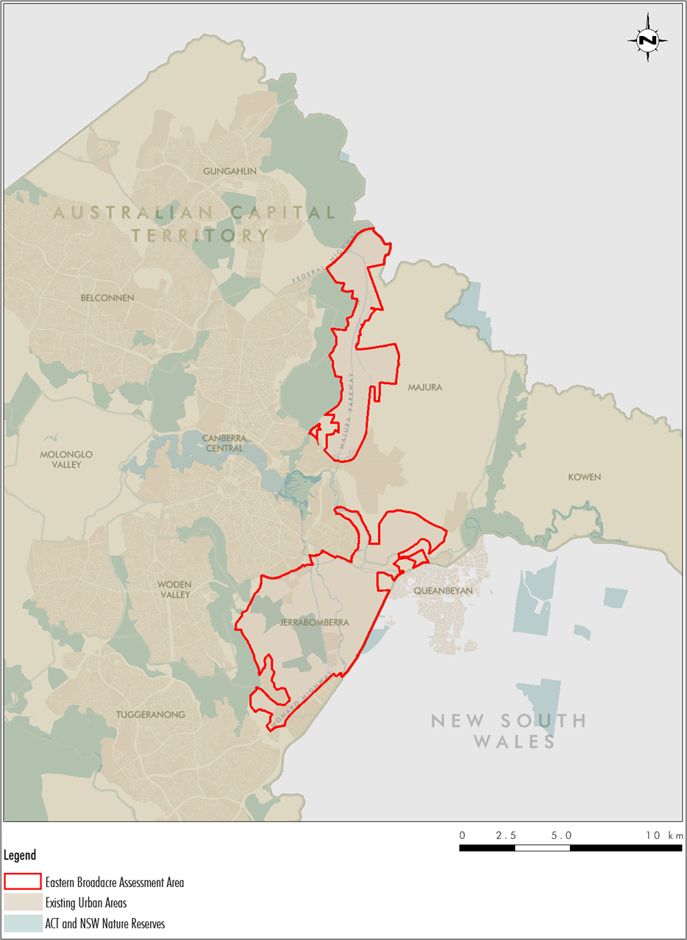
Figure 1 – Eastern Broadacre Strategic Assessment area
Where is the project up to?
In April 2024, an initial draft Eastern Broadacre Strategic Assessment (EBSA) was submitted to the Australian Government’s approval body, the Department of Climate Change, Energy, the Environment and Water (DCCEEW).
DCCEEW provided comments on the draft documentation in July 2024. As a result, further studies and ecological surveys are being undertaken to inform the final draft strategic assessment.
The ACT Government’s City and Environment Directorate (CED), with the support of consultants, will be undertaking the following ecological surveys support the finalisation of the EBSA.
- Striped legless lizard surveys from late August to December 2025
- All other ecological surveys over 2025-26 and 2026-27, including vegetation mapping and habitat mapping, including for Golden sun moth, Pink-tailed worm lizard, Canberra grassland earless dragon and woodland birds
What happens next and how can I get involved?

The final draft strategic assessment is currently scheduled to be submitted to DCCEEW in the third quarter of 2026.

Public exhibition is anticipated to commence later in 2026, subject to agreement by DCCEEW. The draft strategic assessment will be open for comment over a minimum of 28 calendar days.

Following public exhibition, the strategic assessment will be finalised, and a supplementary report will be prepared to address any public comments. The ACT Government will then submit the reports to the Federal Minister for endorsement.

What other work is required in Eastern Broadacre?
In addition to the EBSA, further planning, infrastructure and due diligence activities will be necessary to permit development in Eastern Broadacre.
Specifically, an Environmental Impact Statement and amendments to the Territory Plan will be required to consider environmental impacts at an ACT level and to rezone land, respectively. There will be further opportunities for the public to have their say during both processes.
The timing of land release is contingent on the Federal Minister’s determination of the EBSA.
As such, no sites in Eastern Broadacre are anticipated for release up to 2029-30, as identified in the ACT Government’s 5-year Housing Supply and Land Release Program 2025-26 to 2029-30.

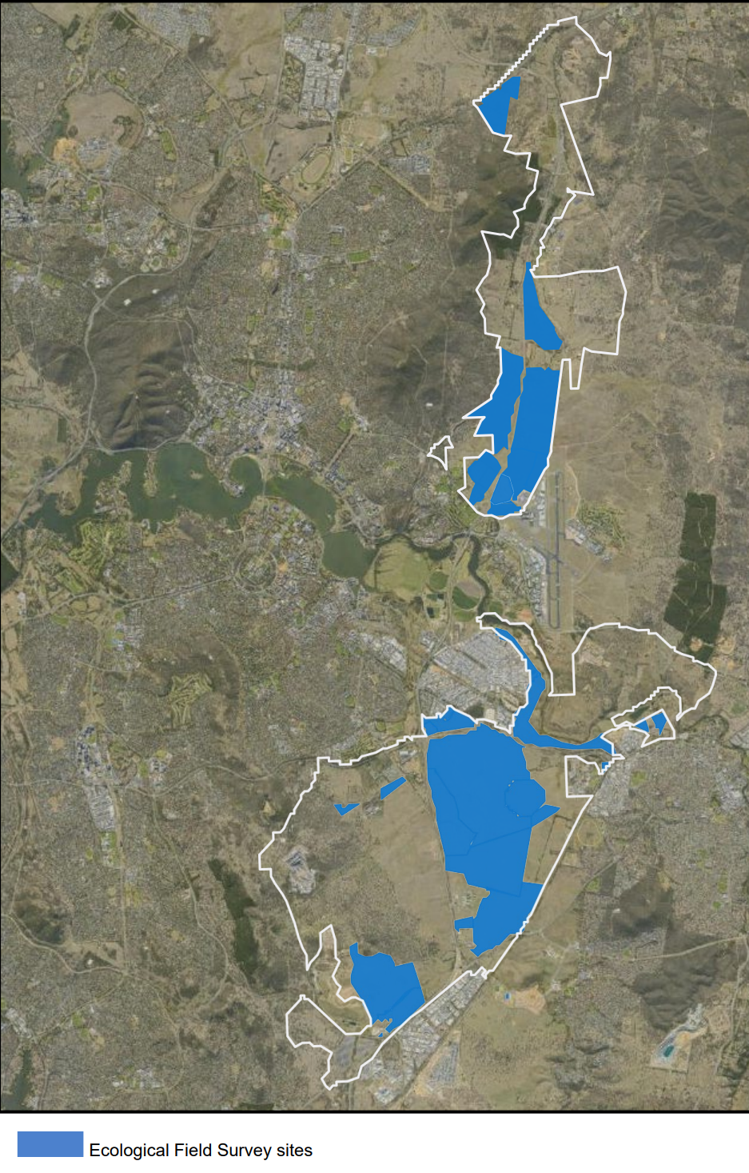
Legend
Assessment boundary
Proposed ecological field survey sites

Figure 2 – Sites that are currently scheduled for ecological field surveys
28
Hume

For more information
For updates and opportunities to be involved during the public exhibition period, visit the CED website at https://www.planning.act.gov.au/planning-projects/eastern-broadacre
There is also information available on the strategic assessment on the DCCEEW website at https://www.dcceew.gov.au/environment/epbc/approvals/strategic-assessments/act-eastern-broadacre

Fact Sheet November 2025
